Required Materials:

A flute (obviously)
Pencil
Assignment notebook

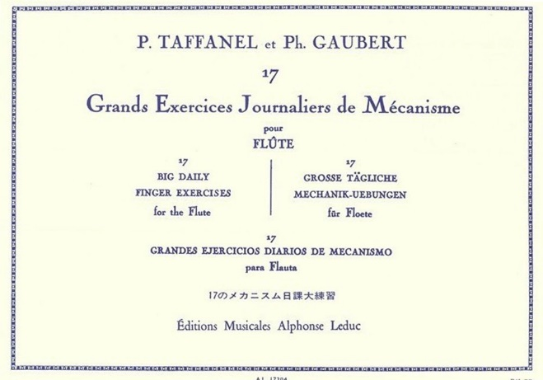
Books:
Taffanel and Gaubert

Universal Edition: 125 Easy Classical Studies for Flute
OR
100 Classical Studies for Flute

A solo book I will assign

Optional:
Marcel Moyse “De La Sonorite Art et Technique” (On Sonority Art and Technique)
OR
Marcel Moyse “Tone Development Through Interpretation”

Recommended items:
Tuner
Metronome
Flute stand

